Child Development and Attachment Fact Sheet for Workers
Early childhood, from birth to age five, is the most critical time for all aspects of development. Not only does early child development lay the foundation for all future developmental stages, but also impacts school readiness, ability to form and maintain relationships, and has implications for future success even into adulthood. The four domains of development are:
- Cognitive development, which includes the ability to think, learn, and solve problems.
- Communication, which includes both language development and nonverbal communication. It also includes both receptive and expressive communication, meaning the ability to understand others as well as express oneself.
- Physical development, which includes both gross and fine motor skills. Gross or large motor skills include sitting, crawling, walking, and later jumping and running. Fine motor skills include learning to hold a spoon and feed oneself, learning to hold a crayon, draw shapes, and pick up small objects.
- Social and emotional development, which includes learning to understand one’s own emotions and the emotions or facial expressions of others, learning to interact with others, sharing, making friends, and self-regulation.
A young child’s development is supported by attachment to a consistent and nurturing caregiver, a safe home environment, proper nutrition, and adequate sleep. Conversely, a young child’s development can be negatively impacted by constantly changing or unresponsive caregivers, chronic poverty, lack of proper nutrition or basic care needs being met, maltreatment or other traumatic or adverse experiences. It is important to assess development and attachment when working with families, not only as it relates to risk of maltreatment, but also because early provision of services gives the child the best opportunity to “catch up” and reduces the risk of future maltreatment.
Each child is unique but there are timeframes in which an infant, toddler, or preschooler may be expected to have mastered certain skills. These “developmental milestones” indicate that 75% of children of a certain age have mastered that skill. Not meeting these milestones within expected timeframes may indicate developmental delays that would benefit from early intervention services. Receiving services for developmental delays as early as possible prepares a child to meet future milestones, interact with peers, and be ready for school.
The Centers for Disease Control and Prevention offer very detailed information on developmental milestones by age, in both English and Spanish, at CDC Developmental Milestones. The website also offers a developmental milestone tracker app which workers may encourage parents to download to their phones.

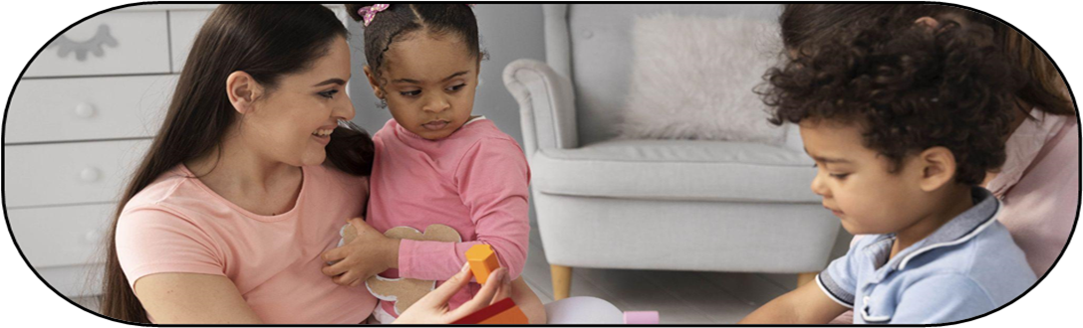

How to Assess and Promote Attachment

The Importance of Attachment
When babies and young children have a healthy, secure attachment to at least one consistent caregiver, they are able to trust that their basic needs will be met. This attachment gives them the security to explore and learn, while having a safe person to rely upon for security and other needs. A secure, healthy attachment is also foundational to building relationships with others. It is the basic building block for social-emotional competence, as babies and young children learn how to interact with others, understand feelings, and form relationships based on the bond to the primary attachment figure.
Conversely, the lack of a healthy, secure attachment with a consistent caregiver in early childhood makes children vulnerable to maltreatment, developmental delays, and behavioral health issues. Attachment may be adversely impacted either by child or parental factors or both. Child factors that may adversely impact attachment to the caregiver include hearing impairment, autism spectrum disorders, undiagnosed medical conditions, history of trauma, and history of instability in caregivers (often due to long hospital stays or out of home care placement changes). Parental factors that may adversely impact attachment include postpartum depression or anxiety, parents’ own history of trauma, lack of positive parenting role models in own childhood, mental health disorders, or substance misuse.

“Serve and return” refers to positive interactions between a caregiver and an infant or young child in which one initiates and the other responds. For example, the caregiver speaks to the infant and the infant smiles or coos in response. The caregiver may speak to the infant again to keep the interaction going. Similarly, a toddler may offer the caregiver an object and the caregiver accepts it, naming the object. The toddler may then offer a different object to be accepted and named by the caregiver. A non-verbal child may also point to a picture in a book, and the caregiver names the picture or talks about it. The child may then point to something different or attempt to also name the picture. These “serve and return” interactions build brain architecture, support development including social, emotional, and language skills, and build healthy attachments.

Promotion of Attachment

Helping young children and their caregivers develop a secure attachment is critical to healthy development, as well as long-term wellbeing. It is important for workers to be attuned to signs of healthy attachment, as well as potential concerns. Observation of the interaction between a baby or young child and the primary caregiver(s) will provide the most information about the quality of the attachment and caregiver/child relationship. Therefore, it is most important to observe the caregiver interacting with the baby or young child whenever possible.
Signs of healthy attachment between parent and caregiver include:
- Child prefers caregiver to others and seeks comfort or reassurance from them. Caregiver offers comfort or reassurance when needed.
- Child goes to caregiver for help when needed. There is evidence of trust to meet needs.
- Caregiver speaks positively about child, understands their needs, and has realistic expectations for their age.
- Caregiver and baby/child engage in eye contact.
- Caregiver talks to child warmly, even if not yet verbal, and baby/child responds.
- Infant responds to primary caregivers’ voice, visually tracks, smiles or babbles when spoken to by caregiver.
- Caregiver and baby/child engage in “serve and return” behaviors.
- Baby/child feels comfortable interacting with others in presence of caregiver.
When working with families, workers may suggest activities to promote healthy attachment, such as:
- Reinforcing the importance of skin-to-skin contact with newborns and infants. Babies may also be soothed by gentle massage or being held.
- Encouraging the parent to talk to infants and toddlers even though they are non-verbal. Parents can talk about what they are doing as they care for the baby or do chores.
- Singing to the infant or toddler. As children get older, they will enjoy singing familiar songs together.
- Reading to infants and toddlers. Even if they are too young to understand the story, the sound of the caregiver’s voice and rhythm of a story is soothing and supports healthy attachment and brain development.
- Making eye contact. Infants start visually tracking the primary caregiver(s) at a very young age.
- Always holding while feeding, whether breast or bottle fed. Bottles should never be propped. Even when an infant starts to hold a bottle, holding while feeding promotes bonding and attachment.
- Engaging in serve and return activities.
If concerns about attachment are identified, the family should be referred for comprehensive evaluation and services, whether the child remains in the home or enters care.

